Part A - Understand the Problem: AI OFF
SmartCare needs a small prototype that allows a receptionist to record patient appointments. Each appointment records patient name, practitioner name and appointment time.
What data must be stored?
- ( The patients name, contact details). ( The practitioners name and contact details and office / work room). ( The appointment’s time and date, Duration: how long the appointment goes for, purpose of the visit and appointments status, for instance, scheduled, completed, no show or in progress).
What functions might be useful?
- Creating the appointment: (The patient_name, Practitioners_name, Date/Time.)
- Cancelling the appointment: (appointment status = cancelled )
- Rescheduling the appointment: ( Appointment time and date , updated,)

What could go wrong?
- Duplicate: 1 patient could be mistakenly booked twice.
- Wrong time and date
- Missing information, such as pateints contact details, or haven’t chosen a practitioner.
- 2 patients booked, at the same time, for the same practitioner

What requirements are unclear?
- Is the clinic, in one place only for multiple clinics under the same name. and information
- Are the practitioner timetable fixed or flexible
- Are the appointments duration limited, or flexible
- Is it walk-in and by appointment or just by walk in, or just by appointment only.
- For How long must the patients data be help in the system

Python Task 1: Smartcare clinic appointment booking system.
Limitations
- Both Codes run the same thing, but the enhanced version is structured better, but I, believe it still is missing important points for a real clinic system.
- The code does not have a saving part, so after the code/script end, all booking disappears, unless the script is just to prove that booking an appointment is available.
- Each appointment only stores, the patient’s name, the practitioners name and appointment time, does not store any other details, such as contact/ emergency contact, or for instance past records.
- There’s no code for checking a double-booking session, whether it’s for the patient or the practitioner.
- It only checks for “ no patient name, return/ can be left empty, doesn’t check for the time/date and chosen practitioner.

Part C- Task 1,

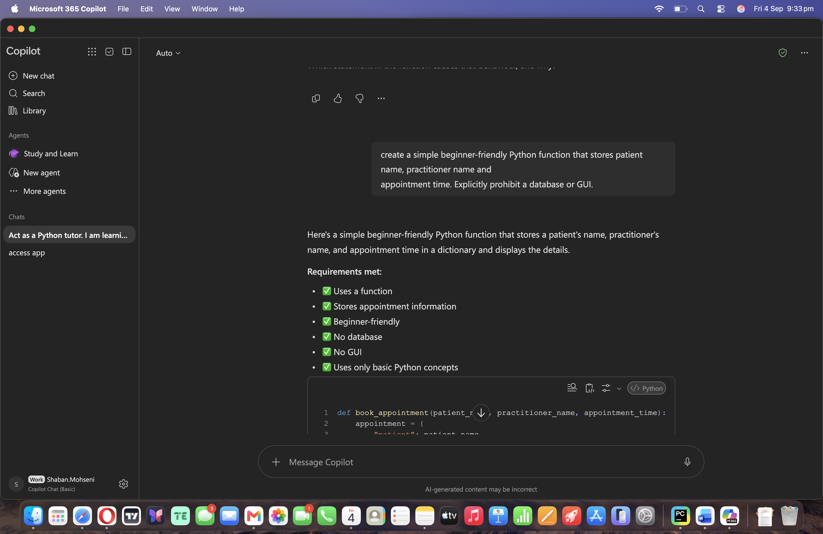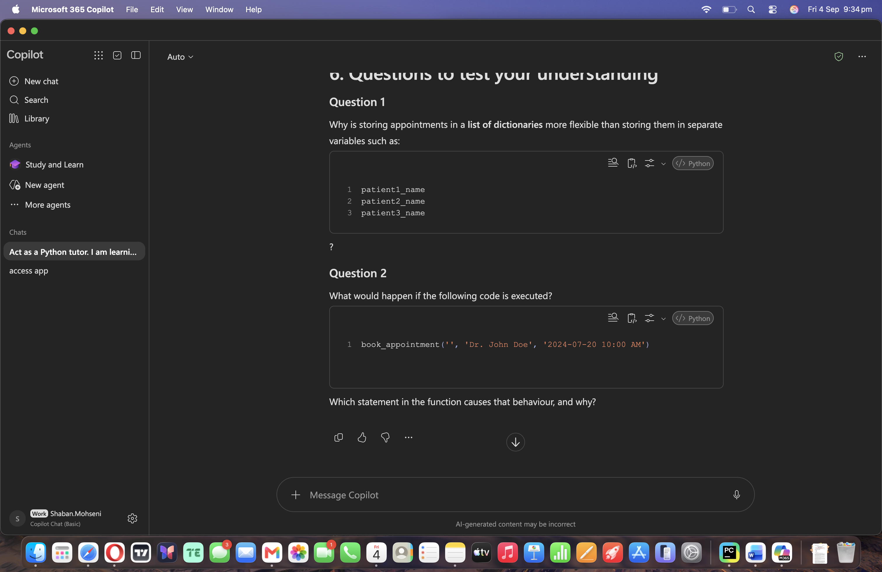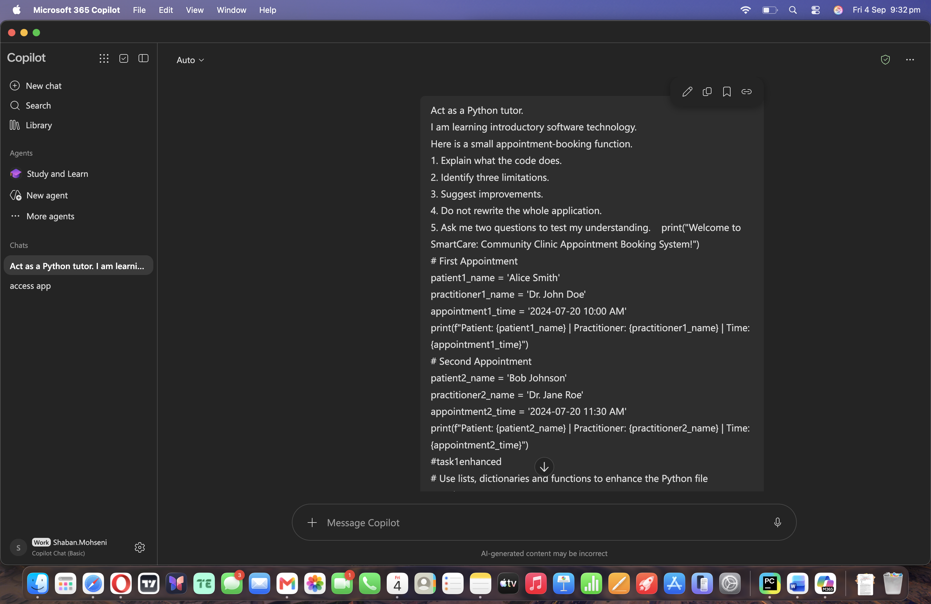
1. What the first program does

2. The first program is a very simple appointment display program.
Steps
3. Prints a welcome message.
4. Creates variables for the first appointment:
Patient name, Practitioner name, Appointment time
5. Prints the first appointment using an f-string.
6. Creates variables for the second appointment.
7. Prints the second appointment.

2. What the enhanced program does
The second version introduces:

A list (appointments)
A dictionary (each appointment record)
Functions (book_appointment() and display_appointments())
Basic validation
What do the codes/function mean:
Function 1: def book_appointment(patient_name, practitioner_name, appointment_time):

This function:

Receives appointment details.
Checks that the patient’s name is not empty.
Creates a dictionary.
Adds the dictionary to the appointments list.

Function 2: def display_appointments():
This function:
- Checks whether any appointments exist.
- Prints a message if none exist.
- Loops through all appointments.
- Displays each appointment.

At least five limitations:

Limitations of Program 1
- Hard-coded data
Appointments are manually typed into variables.
Example: patient1_name = 'Alice Smith'
- Adding a third appointment requires creating more variables and mor print statements.

2. No data storage structure
Appointments are stored in separate variables rather than a list or dictionary.
This becomes difficult to manage as the number of appointments grows.

3. No functions
The program repeats code instead of using reusable functions. Repeated code is harder to maintain.
- No validation

- A user could leave the patient’s name blank, and the program would still run.

6. Cannot scale
To display 100 appointments, you would need hundreds of variables and print statements.

7. No duplicate checking
- the system allows 2 appointments to be booked for instance :
1: book_appointment('Alice', 'Dr. John Doe', '10:00')
2: book_appointment('Alice', 'Dr. John Doe', '10:00')

Suggested improvements

Improvement 1: Validate all inputs
Check that:
- patient name is provided
- practitioner name is provided
- appointment time is provided

Improvement 2: Validate date format
Use Python's datetime module to ensure dates are valid.
Example format: YYYY-MM-DD HH:MM

Improvement 4: Check scheduling conflicts
Prevent two patients from booking the same practitioner at the same time.

Improvement 5: Save data permanently
Store appointments in:
- a text file
- CSV file
- database
so they remain available after the program closes.

Improvement 6: Add appointment management
Provide functions such as: cancel_appointment(), update_appointment(), search_appointment()

Questions to test your understanding

Question 1
Why is storing appointments in a list of dictionaries more flexible than storing them in separate variables such as:
- Having a list of dictionaries is far more flexible because it allows many appointments to be stored in one format, on top of this, adding new appointments can be added without creating new variables, which this allows the data to be processed using loops and functions.

Question 2
What would happen if the following code is executed? book_appointment('', 'Dr. John Doe', '2024-07-20 10:00 AM')
- This function raises a ValueError, because the patients name is an empty string, the statement if not pateint_name: detects the empty value and triggers raise ValueError ( Patient name cannot be empty” which the script returns the user back to the patients name filling section, which is to prevent invalid appointment recodes from being stored in the system.

Written By human vs AI
Question | Human | AI
Easy to understand? | The human written one is easy to understand, but missing certain points, | Is it understandable, and beginner friendly
Runs successfully? | Yes the First program runs, but it doesn’t allow you to fill in the form, rather it just prints out the given format and the second script ( enhanced version, does not, as it gives too many errors | It runs, but it does not display any information, it just runs without any issue.
Uses only required features? | Yes, the basics needed for just booking an appointment, without any other roles, for instance saving and storing data and having a clean, understandable structure | It does gives the basic needs feature for the task, and relatively the same as the Human written one.
Adds assumptions? | What assumptions | It did make changes to the script, that was need, such as time and practitioners name cannot be left empty.
Handles errors? | Yes the minor errors such as patient name left blanked. | Yes, looking at the script
Could I explain it? | Yes | Yes

Part F - Verify Behaviour
• Normal appointment: Works fine doesn’t give any errors

• Blank patient name: The AI version does not have return to patient name left empty. And the human written one didn’t run after making several adjustments.
• Two appointments for the same practitioner/time
• Strange input such as patient_name=None or appointment_time=None

Part G - Improve One Thing
Choose exactly one controlled improvement, for example: if not patient_name: raise ValueError("Patient name cannot be empty")
It would have to be ValueError on patients name, practitioner name and appointment time, ( Cannot be empty.

Part H - Reflection (150-250 words)
What did you build before using AI?
- I build a simple appointment booking system, that track the patients name, practitioners name and appointment time, for s small clinic
What did AI help you understand?
- There were some functions that I missed during the tutorial sessions, that I didn’t understand what the purposes of them were, or when can they be used and how should they be used. But I still had some errors using them, It was helpful or learning them, other than that, there was not much into it, since I struggled to create the script.

Did AI make assumptions?
It did make impovments to the script but, it certainly forgot many points that was mentioned to include and add changes and improvement to the original script.

